**Lab No.00**

01. Write pseudo-code for Example 5 of Lab 01.

NUMBER num1, num2, num3

INPUT num1

INPUT num2

INPUT num3

IF num1 > num2 AND num1 > num3 THEN

OUTPUT num1 + " is the maximum number"

ELSE IF num2 > num3 THEN

OUTPUT num2 + " is the maximum number"

ELSE

OUTPUT num3 + " is the maximum number"

ENDIF

END

02. Write pseudo-code and draw flow chart. Ask a user to enter exam scores for five different courses and determine whether the student is passing or failing the course. Calculate the average score, the number of failed courses, and the number of passed courses. To confirm your solution, trace through the designed flowchart and pseudo-code by using the following

test case: 88, 65, 45, 23, 77.

BEGIN

NUMBER score1, score2, score3, score4, score5, passed, failed, total

INPUT score1

INPUT score2

INPUT score3

INPUT score4

INPUT score5

total = score1 + score2 + score3 + score4 + score5

passed = 0

failed = 0

IF score1 >= 50 THEN

passed = passed + 1

ELSE

failed = failed + 1

ENDIF

IF score2 >= 50 THEN

passed = passed + 1

ELSE

failed = failed + 1

ENDIF

IF score3 >= 50 THEN

passed = passed + 1

ELSE

failed = failed + 1

ENDIF

IF score4 >= 50 THEN

passed = passed + 1

ELSE

failed = failed + 1

ENDIF

IF score5 >= 50 THEN

passed = passed + 1

ELSE

failed = failed + 1

ENDIF

OUTPUT "The average score is " + (total / 5)

OUTPUT "The number of passed courses is " + passed

OUTPUT "The number of failed courses is " + failed

END

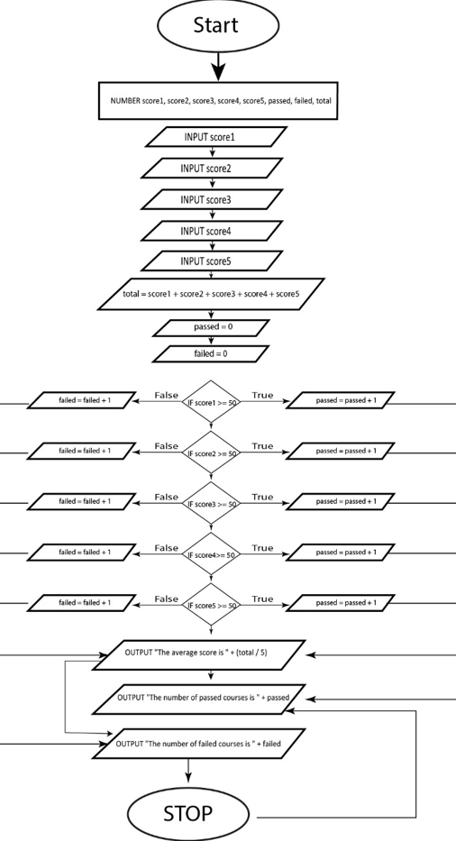

03. Ask a user to enter a number and then display the factorial of the entered number.

#include <stdlib.h>

int main() **Out put:**

{ int n, fact = 1;

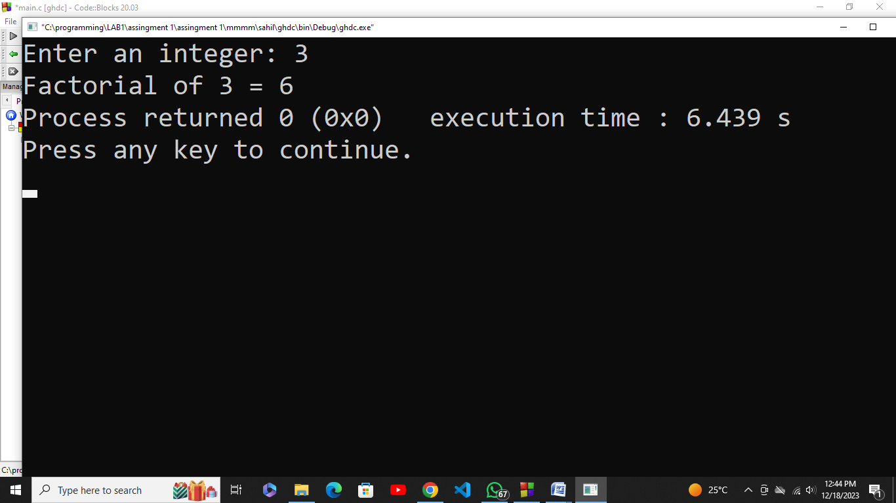

printf("Enter an integer: ");

scanf("%d", &n);

if (n < 0)

printf("Error! Factorial of a negative number doesn't exist.");

else {

for (int i = 1; i <= n; i++) {

fact *= i;

}

printf("Factorial of %d = %d", n, fact);

}

return 0;

}

04. One of the jobs that Joe Roberts has been given at work is to order special paper for a report for a board meeting. The paper comes in reams of 500 sheets. He always makes five more copies than the number of people that will be there. Joe wants to know how many reams of paper he needs for a meeting. He can order only whole, not partial, reams. Assume the required number of pages will not equal an exact number of reams. Test your solution with the following data: The report is 140 pages long. There will be 25 people at the meeting.

#include <stdio.h>

int main() { **Out put:**

int people = 25;

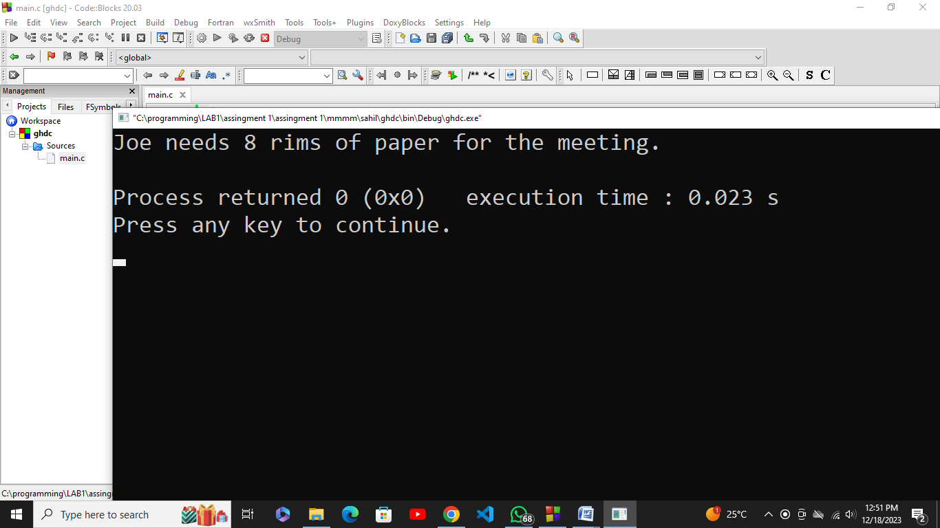

int pages = 140;

int copies = people + 5;

int total_pages = copies * pages;

int reams = (total_pages / 500);

printf("Joe needs %d rims of paper for the meeting.\n", reams);

return 0;

}

05. Joe would like to build several bookcases that are different heights and widths. All will be 12 inches in depth. The bookcases will have three shelves, in addition to the bottom and the top. Write a solution to print the number of feet of 12-inch-wide boards that will Joe need to complete a bookcase, given the height and width.

#include <stdio.h>

int main() {

int height = 6;

int width = 3;

int depth = 12;

double board_feet = (height * width * depth) / 12.0;

printf("Joe needs %.2f board feet of 12-inch-wide boards for the bookcase.\n", board_feet);

return 0;

}

**Out put:**

